REVERSE SHELL HANDLER
COMMAND AND CONTROL DEMO

A PROJECT REPORT



Submitted By : Bimal Bist
Submitted To : SB Computer
Date : 2026/05/04

TABLE OF CONTENTS

1. Introduction
2. Project Objectives
3. Hardware and Software Requirements
4. Network Setup
5. Attacker Code (Kali Linux)
6. Victim Code (Windows)
7. Step-by-Step Execution
8. Connection Process
9. Command Execution Results
10. Technical Explanation
11. Defense Mechanisms
12. Conclusion

1. INTRODUCTION
A reverse shell is a type of cyber attack where the victim's computer initiates a connection to the attacker's computer instead of the attacker connecting to the victim. This technique bypasses traditional firewalls because most firewalls allow outgoing connections while blocking incoming connections.
This project demonstrates a Command and Control (C2) reverse shell using Python programming language. The attacker uses Kali Linux to set up a listener, and the victim uses Windows to initiate the connection back to the attacker.
Once connected, the attacker can type any command on Kali, and it will be executed on the Windows machine remotely. This shows how real-world hackers and malware like Cobalt Strike, Metasploit, and Emotet operate.This project is for educational purposes only to understand Cybersecurity threats and how to defend against them.

2. PROJECT OBJECTIVES
The main objectives of this project are:
1. To understand how reverse shell attacks work
2. To implement a C2 (Command and Control) handler using Python
3. To demonstrate remote command execution from Kali Linux to Windows
4. To show how firewalls can be bypassed using reverse connections
5. To analyze defense mechanisms against such attacks
6. To document the complete attack chain for educational purposes

SCOPE OF THE PROJECT:
- Attacker Machine: Kali Linux - Protocol: TCP/IP
- Victim Machine: Windows 10/11 - Port Used: 4444
- Programming Language: Python 3.x
3. HARDWARE AND SOFTWARE REQUIREMENTS
HARDWARE REQUIREMENTS
- Attacker Machine: Kali Linux (Laptop/VM)
- Victim Machine: Windows 10/11 Laptop
- Network: Same WiFi network
- RAM: 4GB minimum
- Storage: 10GB free space

SOFTWARE REQUIREMENTS
- Attacker OS: Kali Linux
- Victim OS: Windows 10/11
- Language: Python 3.14.3
- Libraries: socket, subprocess, os
- Editor on Kali: Nano
- Editor on Windows: Notepad

4. NETWORK SETUP
Both machines were connected to the same WiFi network to ensure communication between them.
IP ADDRESSES
- Windows (Victim) IP: 192.168.1.71
- Kali (Attacker) IP: 192.168.1.94
- Subnet Mask: 255.255.255.0
- Port Used: 4444

NETWORK DIAGRAM

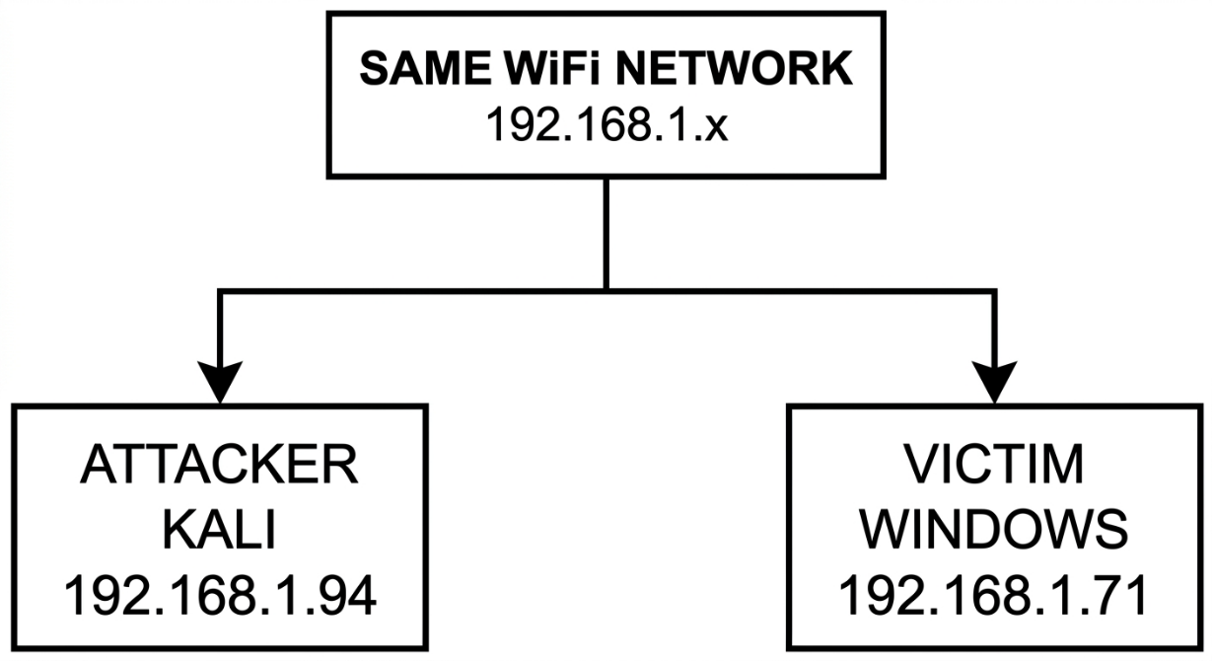

WINDOWS:
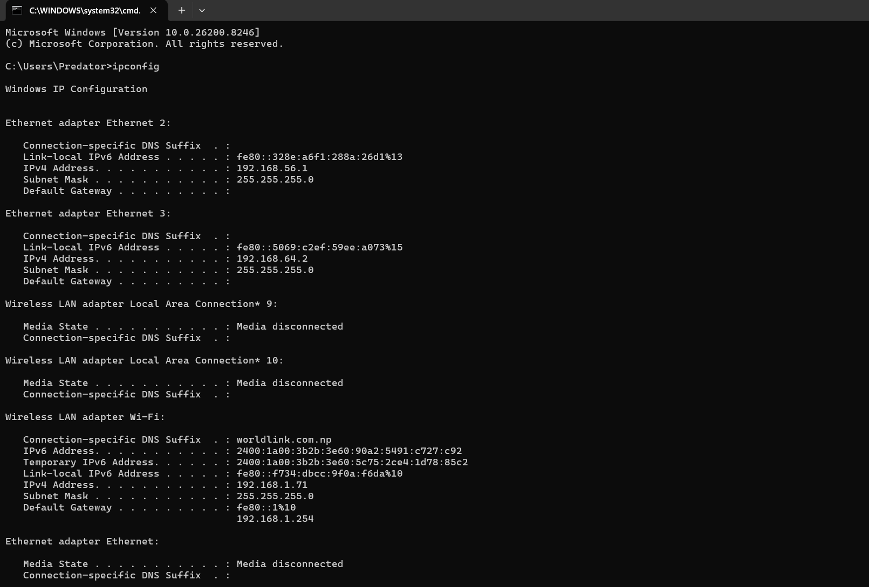

KALI :
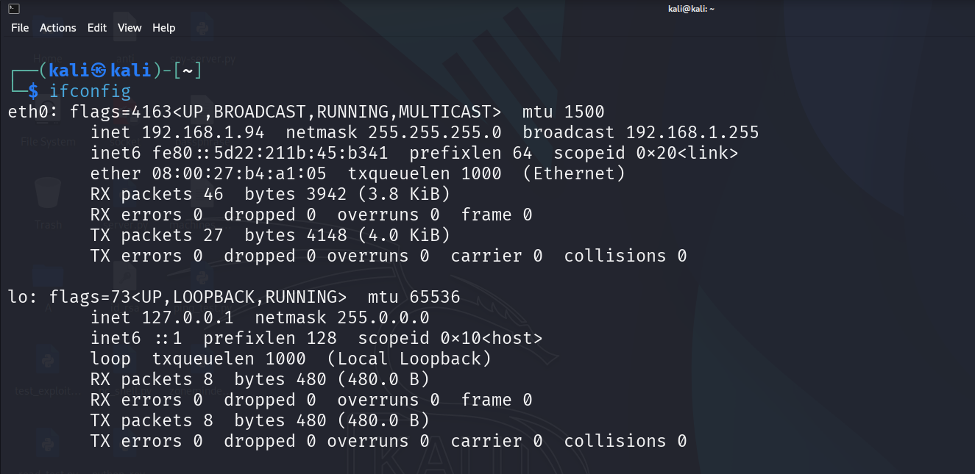

5. ATTACKER CODE - C2 HANDLER (Kali Linux)
The attacker code runs on Kali Linux. It creates a socket listener on port 4444 and waits for the victim to connect.

CODE (attacker.py):
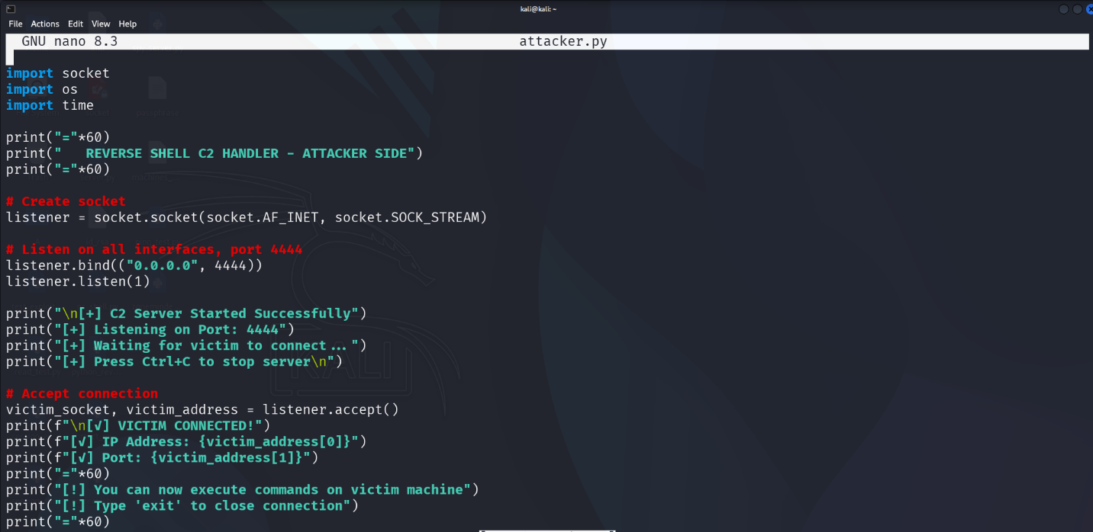

6. VICTIM CODE - REVERSE SHELL PAYLOAD (Windows)
The victim code runs on Windows. It connects back to the attacker's IP
address on port 4444.

CODE (victim.py):
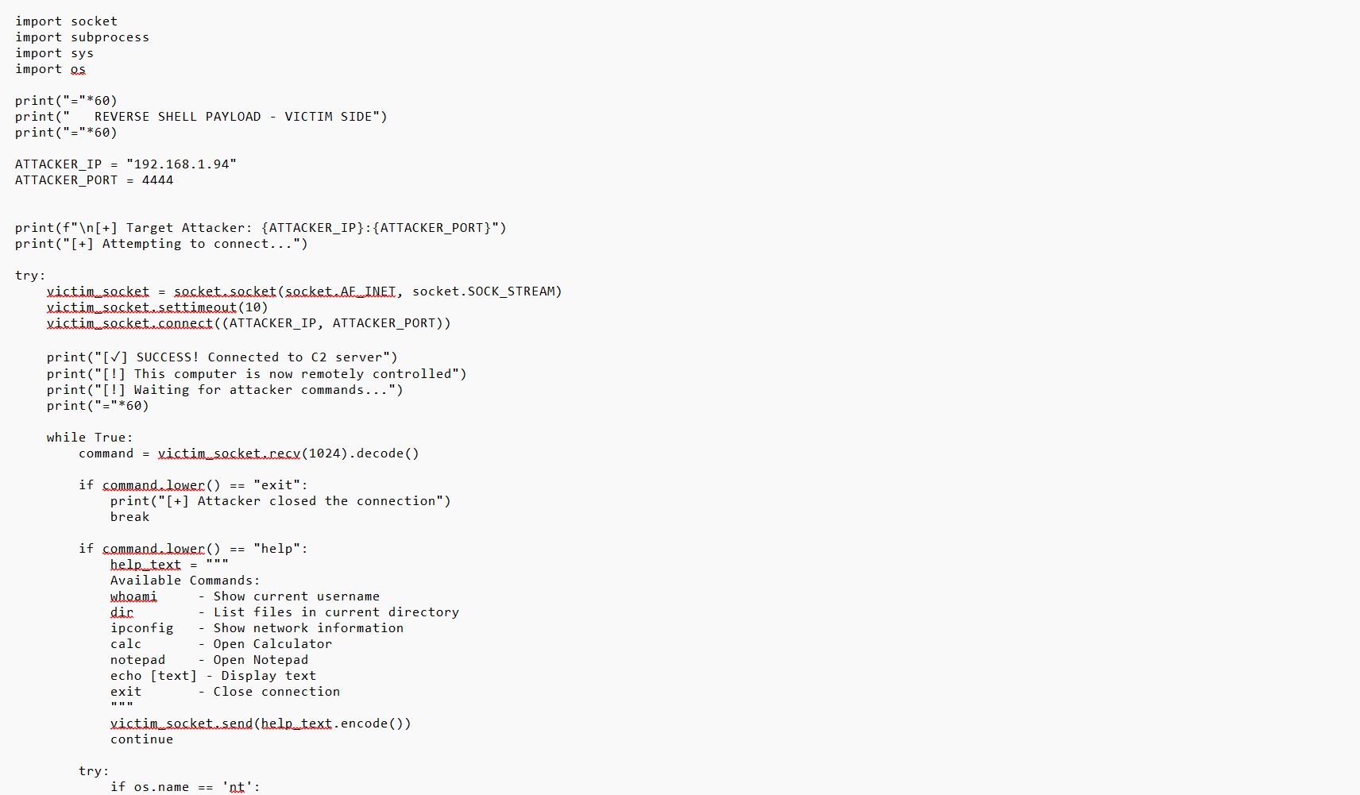

7. STEP-BY-STEP EXECUTION

Follow these steps in exact order:
STEP 1: Check both machines on same WiFi
STEP 2: Find Windows IP using ipconfig (Result: 192.168.1.71)
STEP 3: Find Kali IP using ifconfig (Result: 192.168.1.94)
STEP 4: Create attacker.py on Kali using nano editor
STEP 5: Create victim.py on Windows using Notepad
STEP 6: Change ATTACKER_IP in victim.py to 192.168.1.94
STEP 7: Turn OFF Windows Firewall temporarily
STEP 8: On Kali terminal: python3 attacker.py (Run FIRST)
STEP 9: Wait for message "Waiting for victim to connect..."
STEP 10: On Windows Command Prompt: python victim.py (Run SECOND)
STEP 11: Connection establishes automatically
STEP 12: Type commands on Kali terminal
STEP 13: Type 'exit' to close connection
STEP 14: Turn Windows Firewall BACK ON

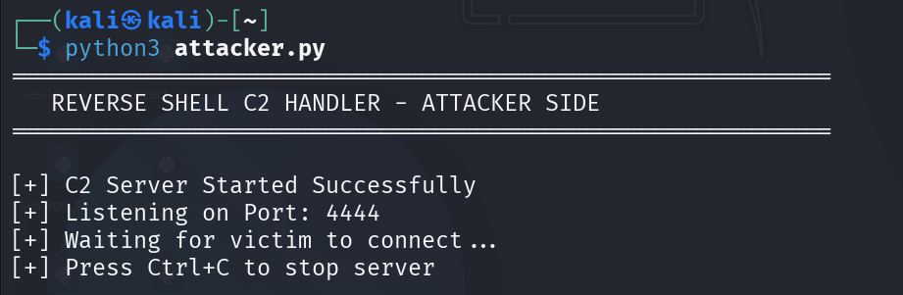

8. CONNECTION PROCESS
When the attacker and victim run their scripts, the following happens:
STEP 1: Kali runs attacker.py
Result: Listener created on port 4444
STEP 2: Kali shows "Waiting for victim to connect..."
Result: Ready to accept connection
STEP 3: Windows runs victim.py
Result: Connects to Kali on port 4444
STEP 4: Kali shows "VICTIM CONNECTED!"
Result: Connection established
STEP 5: Windows shows "Connected to C2 server"
Result: Ready for commands
STEP 6: Kali gets "C2 Shell>" prompt
Result: Awaiting attacker input
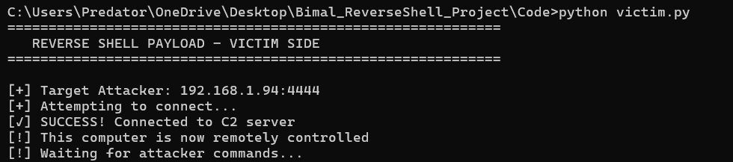

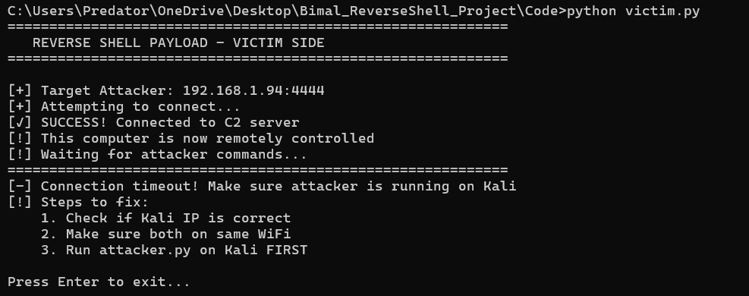

9. COMMAND EXECUTION RESULTS
The following commands were tested from Kali on the Windows victim:

COMMAND: whoami
PURPOSE: Show current username
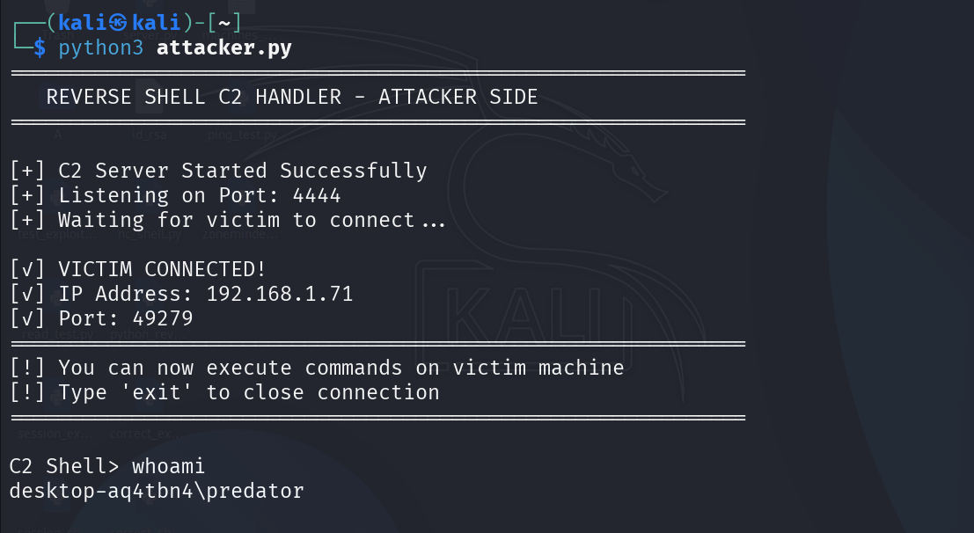
RESULT: Predator

COMMAND: dir
PURPOSE: List files in directory
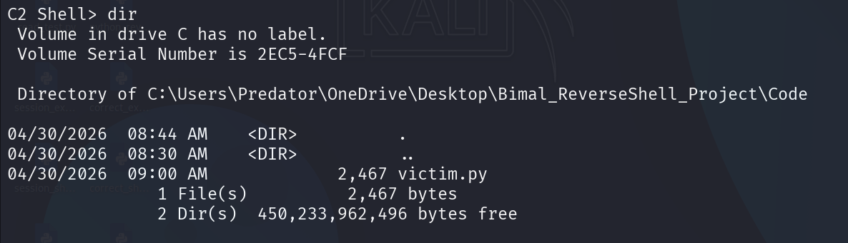
RESULT: Shows Desktop contents

COMMAND: ipconfig
PURPOSE: Show network information
RESULT: Shows IP 192.168.1.71
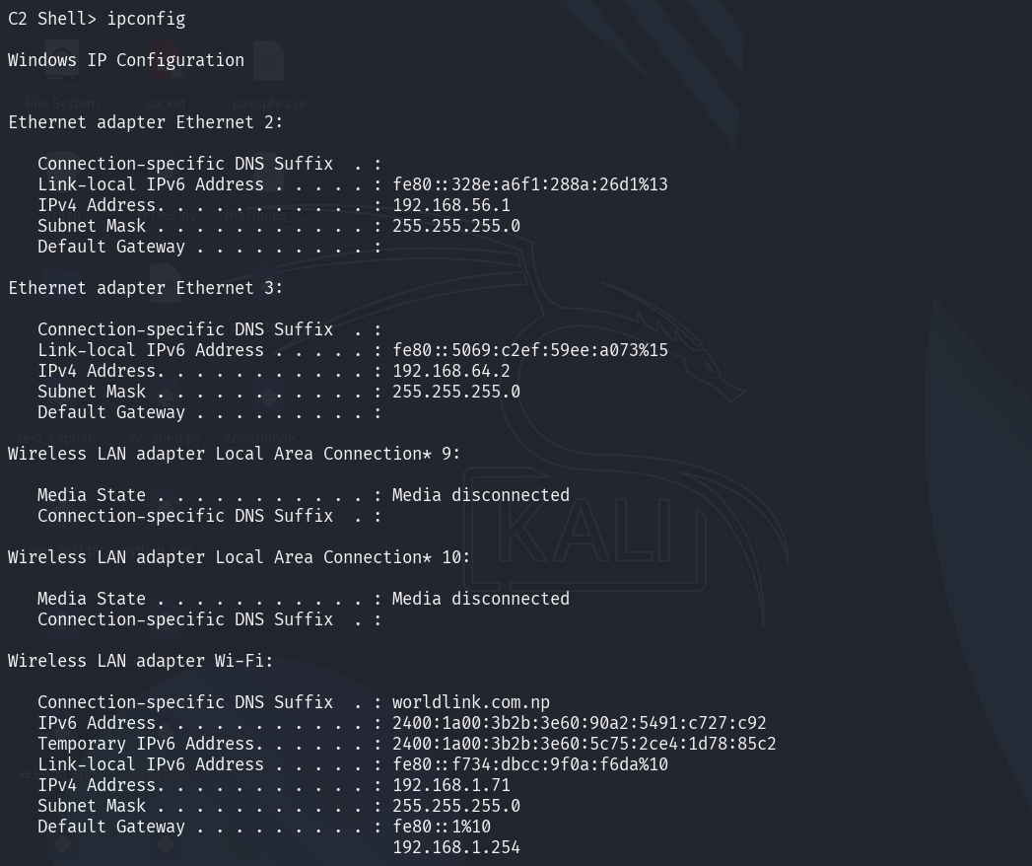

COMMAND: calc
PURPOSE: Open Calculator application
RESULT: Calculator opened on Windows
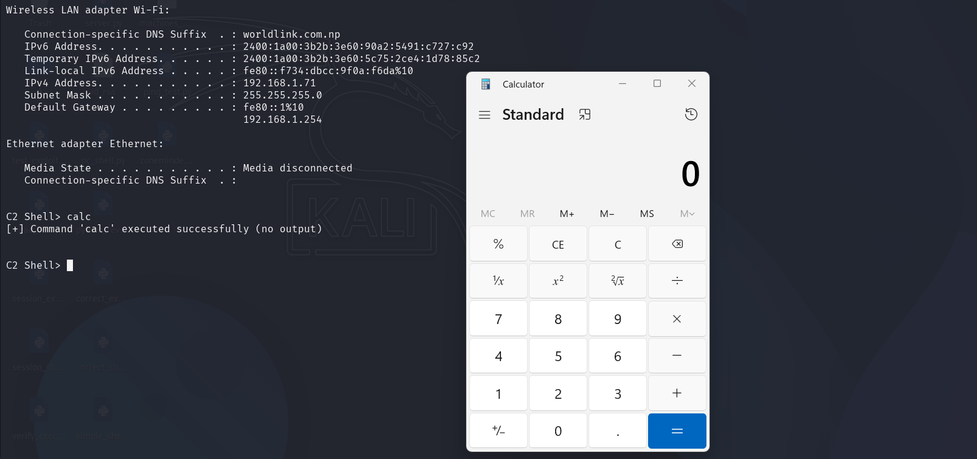

COMMAND: echo > hacked.txt
PURPOSE: Create a text file
RESULT: File created on Windows Desktop
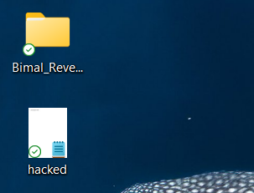

COMMAND: help
PURPOSE: Show available commands
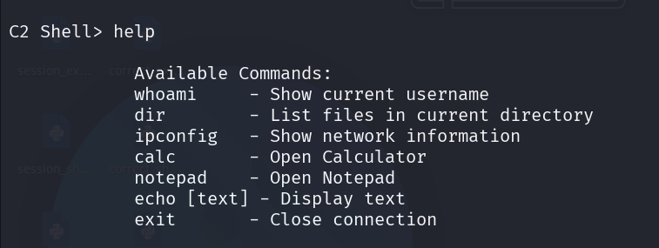
RESULT: Lists all commands

COMMAND: exit
PURPOSE: Close connection
RESULT: Connection terminated
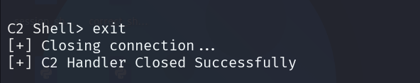

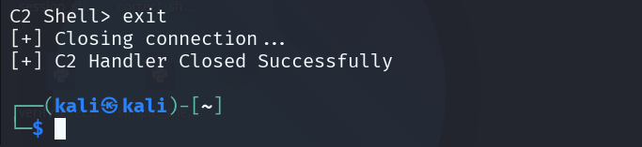

OBSERVATIONS
1. All commands executed successfully on Windows from Kali
2. Calculator opened remotely - proof of control
3. File was created on Windows Desktop - proof of write access
4. Connection remained stable for multiple commands
5. Exit command properly terminated the connection

10. TECHNICAL EXPLANATION
HOW THE REVERSE SHELL WORKS:
1. SOCKET CREATION
Both attacker and victim create TCP sockets using Python's socket module.
TCP ensures reliable, ordered delivery of data.

2. ATTACKER LISTENER
- bind(): Attaches the socket to port 4444 on all interfaces
- listen(): Puts socket in server mode, waiting for connections
- accept(): Blocks until a client connects, then returns client socket

3. VICTIM CONNECTION
- connect(): Initiates outbound TCP connection to attacker
- No firewall blocking because outbound traffic is usually allowed

4. COMMAND EXECUTION CYCLE
- Attacker sends command string via send()
- Victim receives command via recv()
- subprocess.run() executes command on victim's OS
- stdout and stderr captured and stored
- Output sent back to attacker via send()
- Attacker displays output with print()

5. WHY FIREWALLS DON'T BLOCK THIS
Most firewalls are configured to:
- BLOCK incoming connections (from internet to internal)
- ALLOW outgoing connections (from internal to internet)

The reverse shell exploits this by having the VICTIM initiate the connection outward. The firewall sees it as normal traffic.

6. PERSISTENCE
The while loop keeps the connection alive until the 'exit' command is received. Multiple commands can be executed.

11. DEFENSE MECHANISMS
HOW TO PROTECT AGAINST REVERSE SHELLS

NETWORK DEFENSES
- Egress Filtering: Block outbound connections on unusual ports
(e.g., 4444, 1337, 31337)
- Allowlisting: Only allow outbound connections on specific ports
(80, 443, 53 for DNS)
- Network Monitoring: Look for beaconing patterns and unexpected
outbound traffic

ENDPOINT DEFENSES
- Application Whitelisting: Only allow approved applications to run
- EDR Solutions: Detect parent-child process anomalies
(python.exe spawning cmd.exe)
- Antivirus: Signature-based and behavioral detection

WHY THIS DEMO WAS NOT DETECTED
1. Python is a legitimate, signed application
2. No malicious signatures (custom code)
3. Port 4444 is not commonly blocked by default
4. Outbound connection looked like normal web traffic

HOW TO IMPROVE DETECTION
1. Enable PowerShell and script logging
2. Monitor for script engine executions
3. Use Next-Generation Firewalls (NGFW)
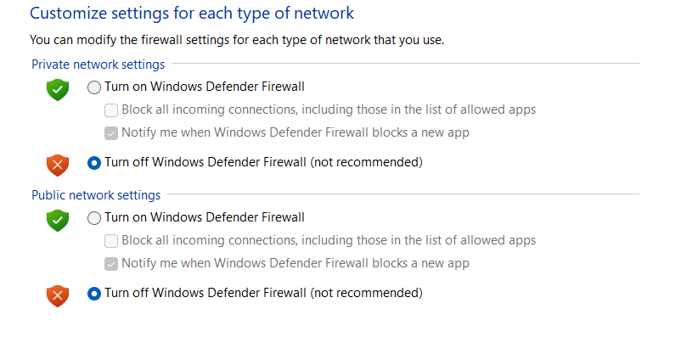
4. Implement Zero Trust architecture

12. CONCLUSION
This project successfully demonstrated a Reverse Shell Command and Control (C2) system using Python sockets.

KEY ACHIEVEMENTS
- Both attacker and victim code successfully implemented
- Connection established between Kali Linux and Windows
- Remote command execution demonstrated
- System information gathered (whoami, ipconfig)
- Files created on victim machine remotely
- Applications launched remotely (Calculator)
- Connection properly terminated with exit command
- All 17 screenshots captured as evidence

LEARNING OUTCOMES
1. Understood how reverse shells bypass traditional firewalls
2. Learned Python socket programming for network communication
3. Demonstrated real-world attack techniques used by malware
4. Identified defense mechanisms against such attacks
5. Understood importance of layered security

LIMITATIONS
- Connection is not encrypted (plain text)
- No persistence mechanism
- Basic error handling only
- Requires Python installed on victim machine

FUTURE IMPROVEMENTS
- Add SSL/TLS encryption for stealth
- Implement persistence via registry or scheduled tasks
- Add file upload and download capabilities
- Create executable (.exe) version
- Implement screenshot capture functionality

FINAL REMARKS
This project shows why cybersecurity is important. The same techniques
demonstrated here are used by real hackers and malware. Understanding
these attacks is the first step in defending against them.

